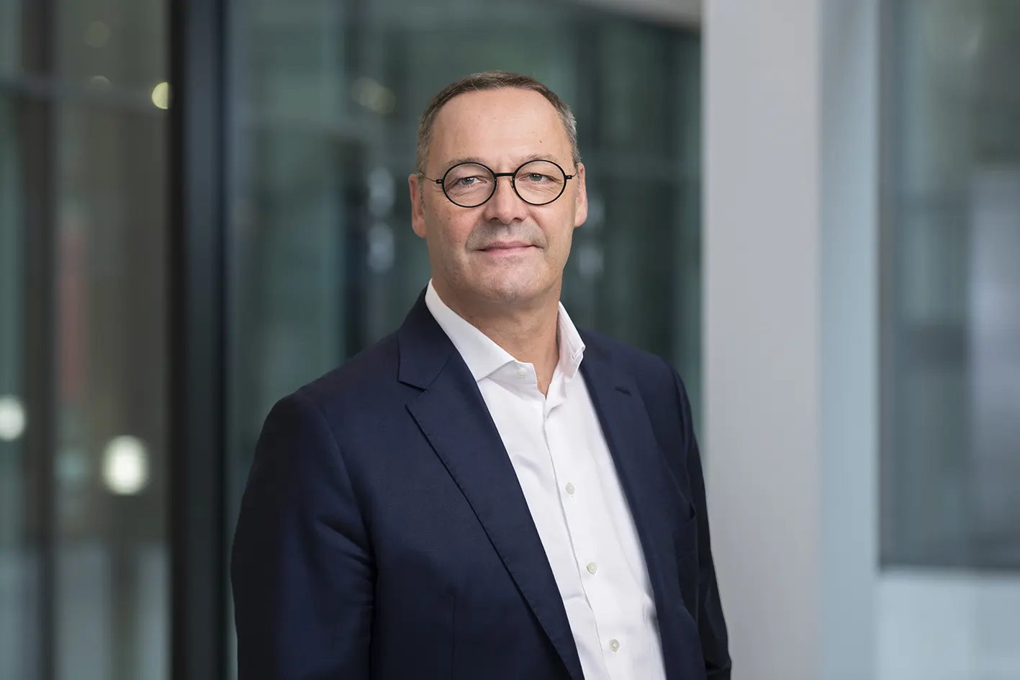
Steel Europe
03|01|2024

Bernhard Osburg – Chief Executive Officer of the Executive Board

Bernhard Osburg has been Chief Executive Officer of thyssenkrupp Steel Europe AG since October 1, 2021. His responsibilities include Strategy & Corporate Development and Innovation. Prior to this he was Chairman of the Executive Board of thyssenkrupp Steel Europe AG since March 1, 2020. He was appointed member of the Executive Board of thyssenkrupp Steel Europe AG in June 2019 with responsibility, among other things, for Sales and Supply Chain Management.

Bernhard Osburg joined thyssenkrupp Steel Europe in 2014. Before being appointed to the Executive Board he was head of sales management, having previously been responsible for the Automotive business unit. Bernhard Osburg has been elected honorary president of the German Steel Federation (Wirtschaftsvereinigung Stahl) for the years 2023 and 2024.

He began his career in 1996 at Johnson Controls Interior GmbH. He worked at ROI Management Consulting AG in Munich as a consultant from 1998 to 2000, before joining the thyssenkrupp Group in 2000, where he has held various positions in sales and technology. From 2009 to 2011 he was head of Sales and Technology at thyssenkrupp Umformtechnik GmbH. From 2011 to 2014 Bernhard Osburg moved to Gestamp Automocion as a member of the executive board, before returning to thyssenkrupp in 2014.

Bernhard Osburg, born 1968, studied mechanical engineering at the universities of Duisburg and Düsseldorf.

