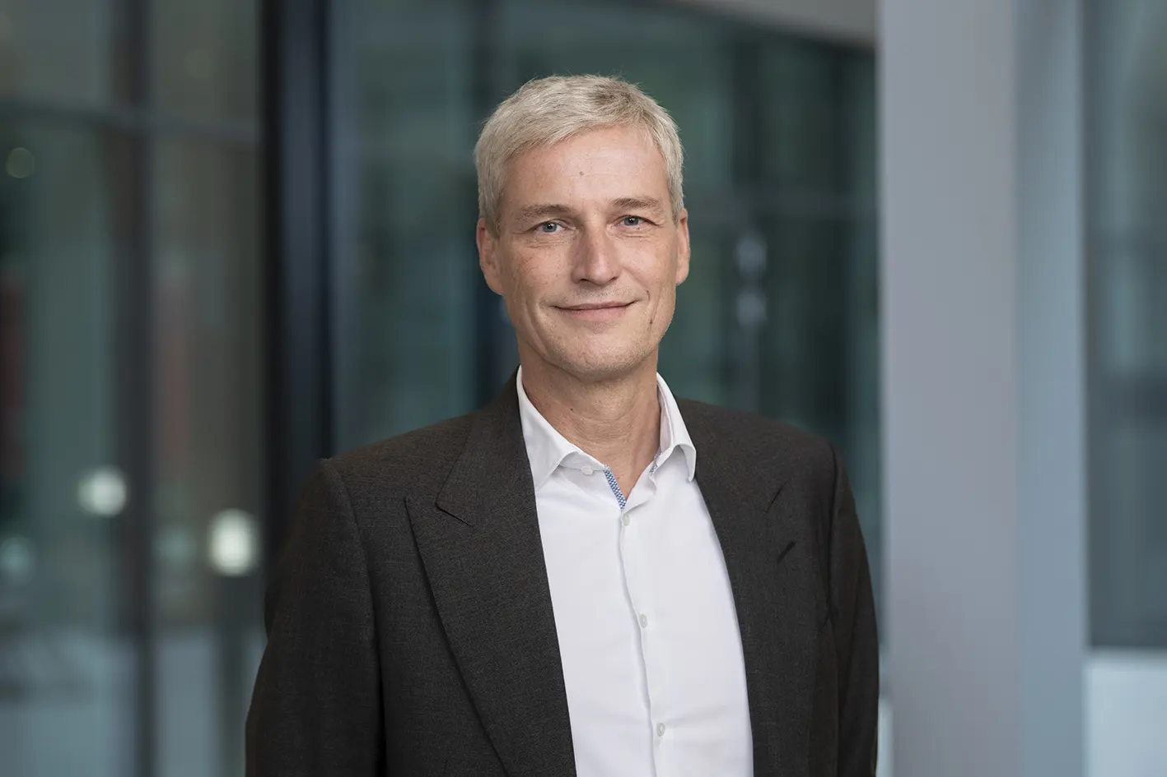
Steel Europe
03|01|2024

Dr. Arnd Köfler – Chief Technology Officer (CTO)

Dr. Arnd Köfler has been a member of the Executive Board of thyssenkrupp Steel Europe AG since 2017. Since May 1, 2022, he has been Chief Technologie Officer responsible for a newly formed integrated transformation directorate. It comprises all activities associated with the decarbonization of the steel production, research and development, as well as the implementation of the optimization of the production network adopted as part of the Strategy 20-30.

Dr. Arnd Köfler began his career in the hot metal department at Hüttenwerke Krupp Mannesmann GmbH (HKM) in 1994. He held various other positions at HKM until 2013, including that of head of burden preparation, head of continuous rounds casting, head of quality and order management and head of crude steel production. He began working for thyssenkrupp Steel Europe AG as head of steel production in 2013, and in January 2016 took over as head of rolling and coating at the Beeckerwerth site.

Dr. Arnd Köfler, born 1967, studied mechanical engineering at Ruhr-University Bochum before gaining a PhD in metallurgy at RWTH Aachen University in 1999.

