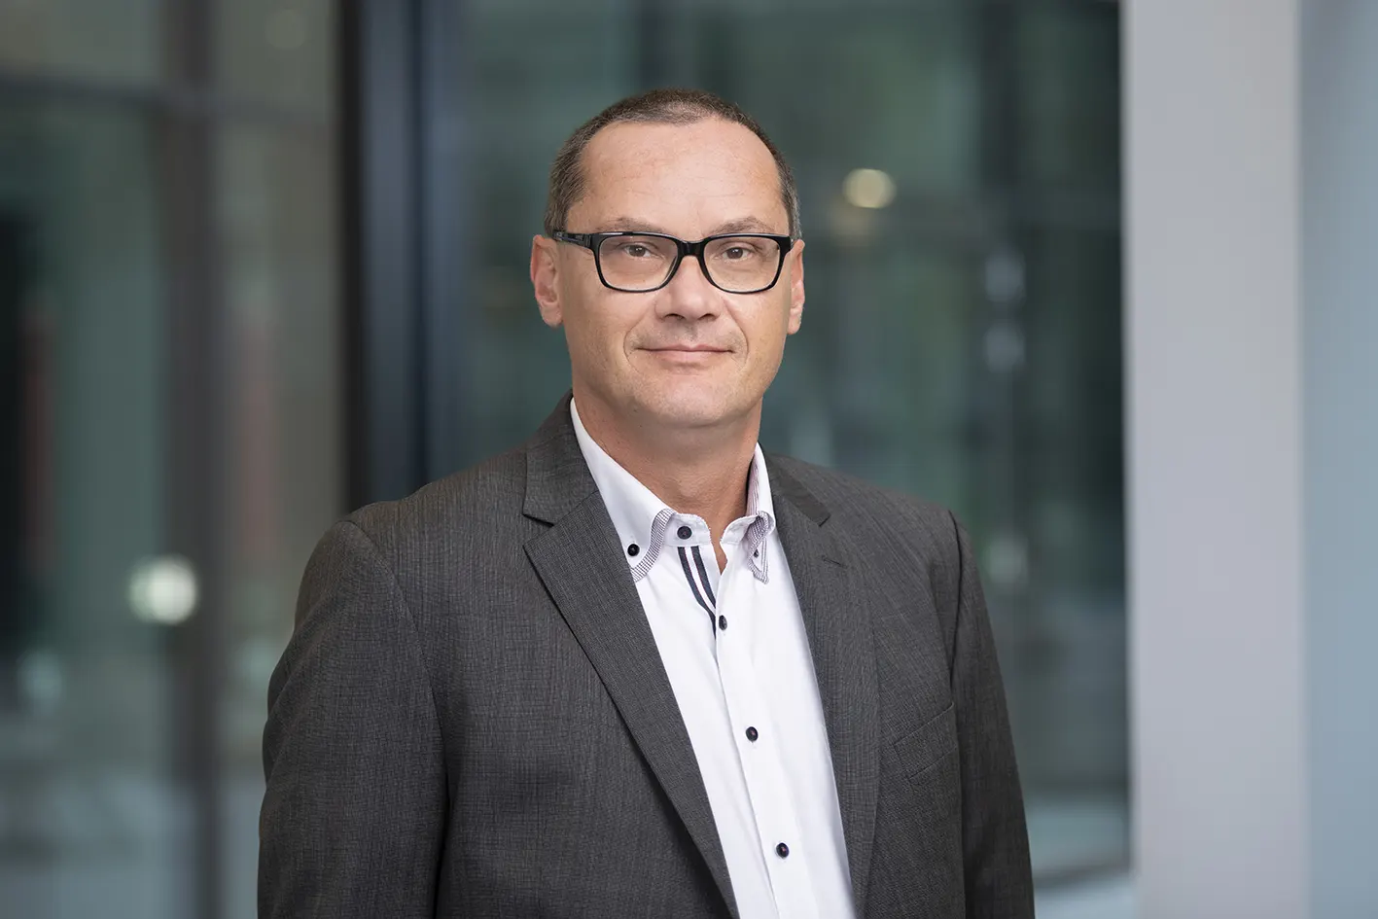
Steel Europe
03|01|2024

Markus Grolms – Chief Human Resource Officer (CHRO)

Markus Grolms has been Labor Director and CHRO of thyssenkrupp Steel Europe AG since April 2020. Prior to that he was Executive Committee Secretary at the IG Metall trade union and Deputy Chairman of the Supervisory Board of thyssenkrupp AG.

He began his career in 1997 at Pilkington Flachglas Automotive. From 1998 to 2007 he worked as a quality assessor at Siemens Mobile, subsequently BenQ Mobile, where he was also an active works council member from 2001. Grolms became an IG Metall trade union secretary in 2007. From 2009 he represented the trade union on the Supervisory Board of thyssenkrupp AG and was appointed Deputy Chairman of this body in 2016.

Markus Grolms, born 1971, studied social sciences in Duisburg and social psychology, political science and law at the Distance University of Hagen.

