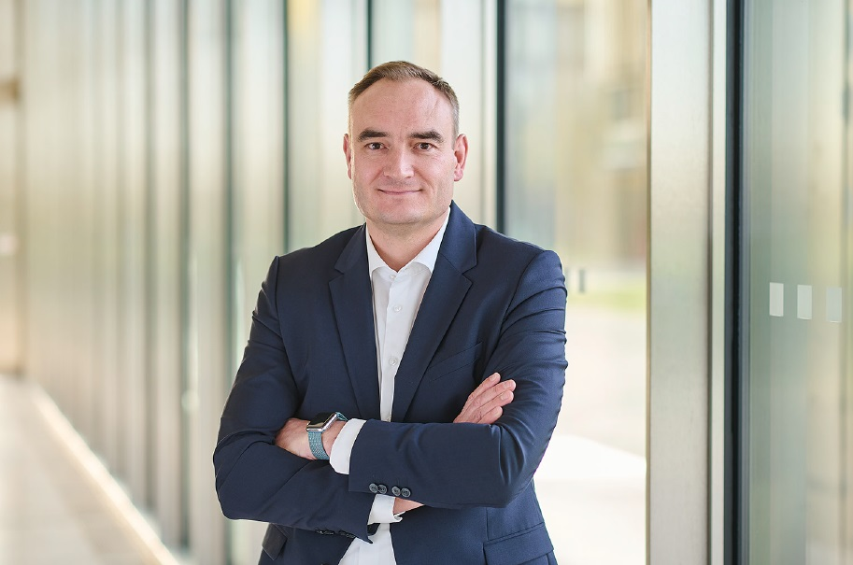
Steel Europe
03|01|2024

Philipp Conze – Chief Financial Officer (CFO)

Philipp Conze has been Chief Financial Officer (CFO) of thyssenkrupp Steel Europe AG since March 1, 2024. Most recently he was CFO of the globally operating Rothe Erde Group (formerly thyssenkrupp Segment Bearings) from 2020 to 2024. He has also been the CFO of thyssenkrupp rothe erde Germany GmbH since 2021.

Philipp Conze joined the thyssenkrupp Group in 2012 and has held several leading positions in the field of controlling. From 2016 to the end of 2019 he assumed overall responsibility for the Group’s Controlling and Financial Accounting function.

Philipp Conze was born in 1975. During his career as an officer in the German Army (Bundeswehr) from 1994 to 2006, he studied economics and organizational sciences in Munich from 1997 to 2001. After attaining a degree in business administration, he completed a part-time Executive MBA program in England in 2005. After holding various management positions in the Bundeswehr, Philipp Conze switched to management consulting in 2006, where he focused on finance and controlling in large companies and corporate groups in a wide variety of industries.

